Ondrian Duncan  Artist/ Visual Arts Educator  Camp Creek Middle School  Fulton County Schools, Ga. | 404-338-0029  Olduncan20@yahoo.com  www.ondrianduncan.weebly.com

Degrees  B.F.A Art /Art Education  University of Georgia  Athens, Ga. | Dec. 2003
Key Professional Appointments  Camp Creek Middle School  Fulton County Schools  Visual Arts Teacher, Intramural Coach, Art Club  Grades 6-8  Fulton County , Ga. | 2004-Current
Visual Arts Curriculum Writer  Responsible for aligning Visual Arts Curriculum with GPS  Fulton County, Ga | Feb-May 2010
Neighborhood Gallery Art s Center  Visual Arts Instructor  Ages 5-13  Atlanta, GA | June 2008
Lesson Plan Writer  Developed lesson plans for other teachers that encompassed current curriculum standards  Fulton County, Ga. | June 2007
Recent Art Shows  National Arts Show  Hartsfield- Jackson International Airport  Atlanta, Ga. | Nov 2012
Glorified Babysitters Club Group Show  Neighborhood Gallery Arts Center  Atlanta , GA | Nov 2010
SHE- Artists Collective  African American Research Library  Atlanta, GA | April 2010
Southwest Arts Center Art Auction  Atlanta, GA | Jan 2010

Selected Series
Moving Series | 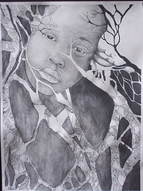 | Self Portraits
Growth Pattern Illuminated Series | 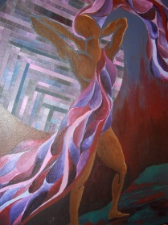 | Media exploration of process and organic pattern growths
Need Series | 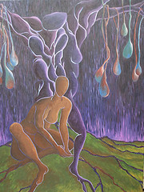 | Ideas of what one needs to move on from situations that just aren’t working.
Other Works can be seen on my Flickr page: www.flickr.com/photos/oduncan

Professional Organizations

Glorified!
A collective of Christian art educators dedicated to personal and professional development.

S.H.E
A collective of African- American art educators joining resources for artistic growth.

Recognitions
Nominated for Teacher of the Year 2012
Camp Creek Middle School

Southwest Arts Center Juried Middle School Show
Winner Best in Show 2010 and 2011
South West Arts Center
Atlanta, GA

Research Interests
On being creative- Multi-media organically layered forms and stitches
On being an educator- experiencing art through creative problem solving

Creative & Research Biography

I consider myself an artist who teaches art to the next generation of artists and art patrons. There was a journey to becoming the Ms. Duncan that I am now. Learning who I had to become to deliver the art education I want for my students was about transitioning my entire school into my formula of art teaching. Becoming Ondrian, the artist, involved building a community of other art educators with similar goals for themselves and their students. These groups, S.H.E and Glorified!, built an environment to discuss teaching art while working on our personal art. I believe that teaching art from the perspective of what it means to work as an artist develops an appreciation for what art is to my students. The students are engaged with what they are doing, because the art making is more meaningful to their personal lives.

